Contents

Left Navigation 2

2.Views 3

2.1.how to ceate view 4

3. Items 5

3.1. New Item 5

3.2. List at the top ribbon area 6

3.3.Adding column 6

3.4.Excel 7

3.5.List setting 7

3.6.Remane the Column 8

3.7. create additional column 9

3.8. Column Ordering 9

3.9.Indexed columns 10

3.10.Views 11

3.11.Tasks 11

3.12.Calendar 12

3.12.1.Tabolar view 14

3.13.Group:Group by department 15

MTM Students 16

3.15.Item level permission 18

3.16.Attachment 18

Re-index 19

Google as index 20

Popup..smaller 20

Audiance 21

Save as a tamplet 22

Download Tamplet 23

Then create new Student list and upload it to get copy 24

Enterprise metadata and keyword settings 25

Information management policy settings 27

Retention 28

Time period 29

Transfer 29

Library 30

Contextual menu 33

Checkout 33

Open the word online or … 34

Add another column 34

Discard 36

**Class5.More on Lists and Libraries**

# Left Navigation

**You may not have left navigation**

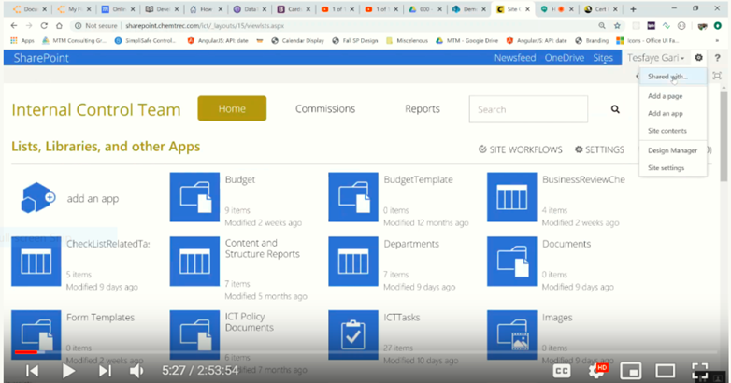

**Differentiate lists and libraries by looking sign of icons**

**Lists, Libraries and another app**

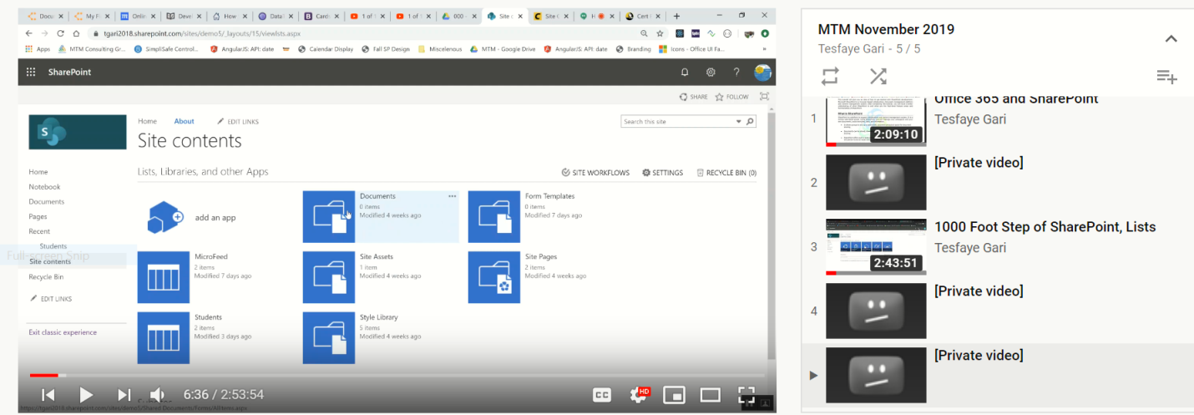

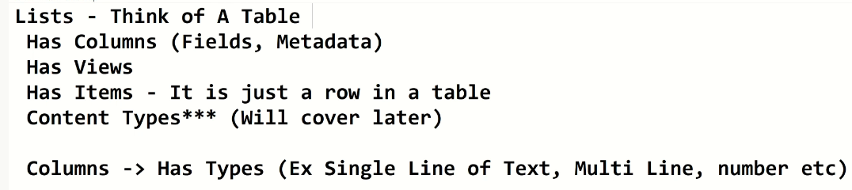

# 2.Views

Is the subset of fields/Lists?

It display some parts of a coulumn

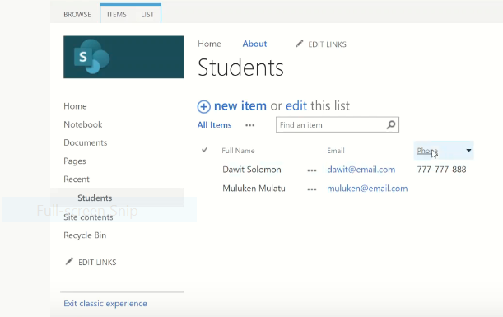

It is used to see some parts of the list or column

## 2.1.how to ceate view

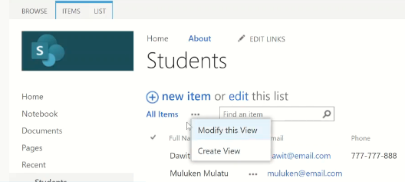

# 3. Items

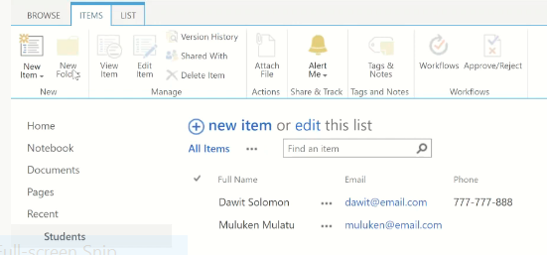

## 3.1. New Item

* New Item=> gives form
* New folder=> available for library
* View Item=>first select the row/rows

By selecting the row=> we can

* Edit
* Delete
* Share…

We don’t goto at the top to do this simply use **ellipse**

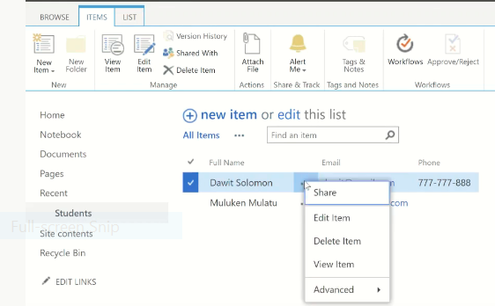

## 3.2. List at the top ribbon area

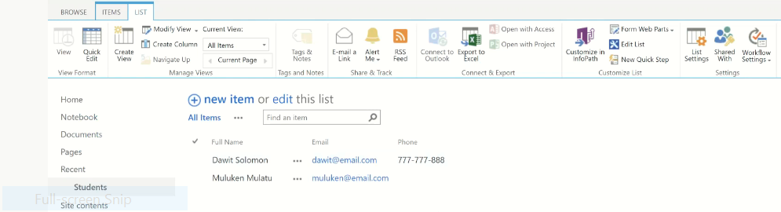

## 3.3.Adding column

**By using modify a view**

**We can add ceated and created by columns from the list**

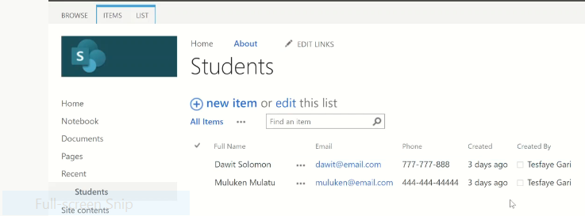

3.4.Excel**:**

* First check the site is created on IE
* Second check local internet connection
* Then export to excel

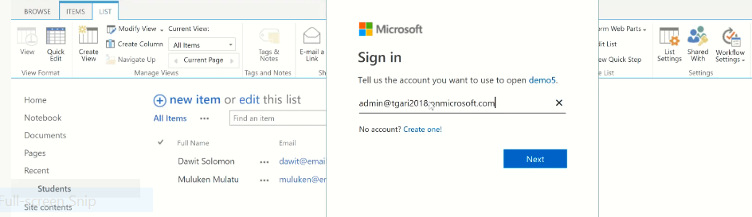



## 3.5.List setting

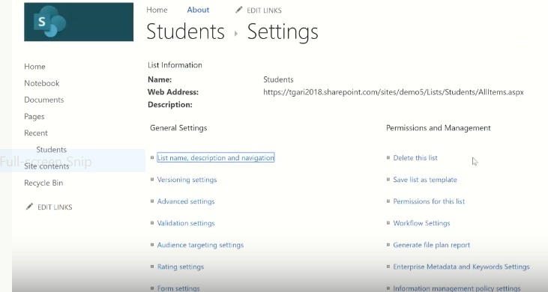

## 3.6.Remane the Column

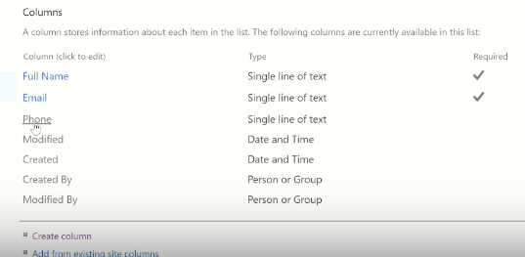

**This is not visible in the table but visible in here.**

**Tasks**

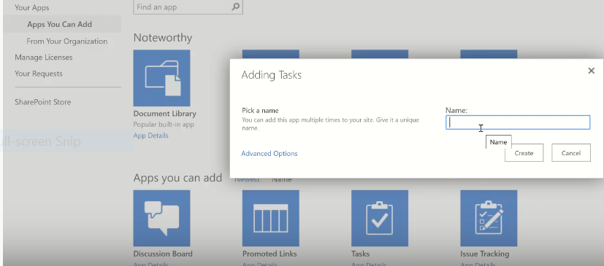

**Instead of title task name**

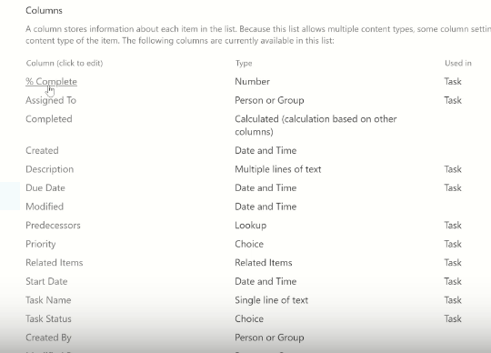

**Predecessor =>one depend by the other**

## 3.7. create additional column

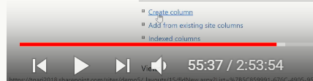

## 3.8. Column Ordering

**To do ordering column**

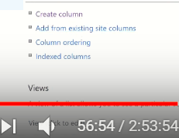

## 3.9.Indexed columns

**i.Take phone#=>inforce unique value**

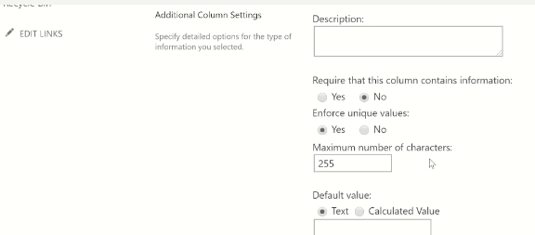

**Ok=>Ok**

**ii. Indexed columns=>create new index**

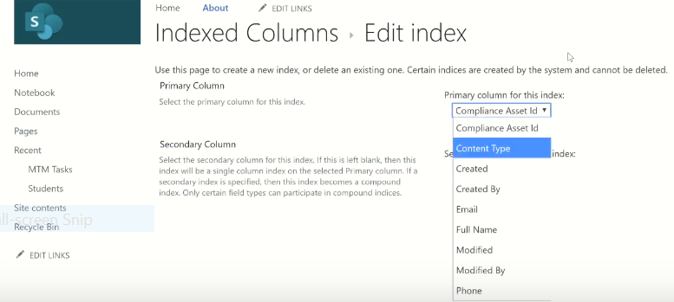

## 3.10.Views

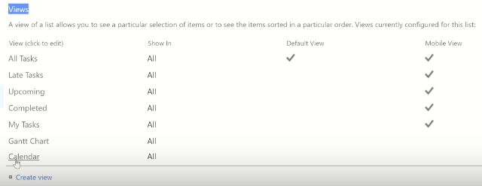

**There are 7 d/t views in the table.1 default view**

## 3.11.Tasks

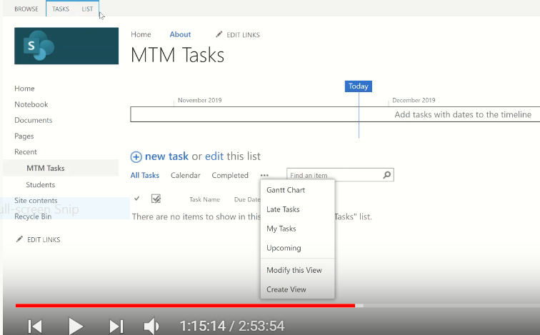

**Views is very nice**

**New Task**

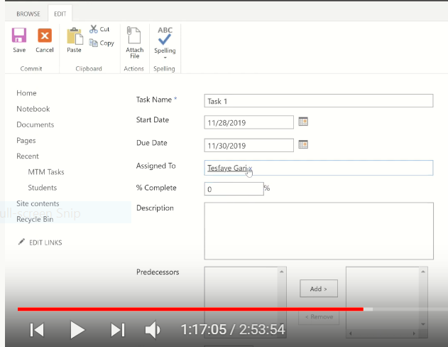

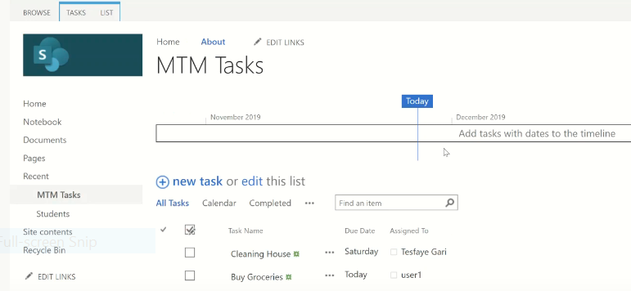

**=>Time line**

## 3.12.Calendar

**My task**

**Upcoming tasks=>starting and ends befor today**

Talk about the following

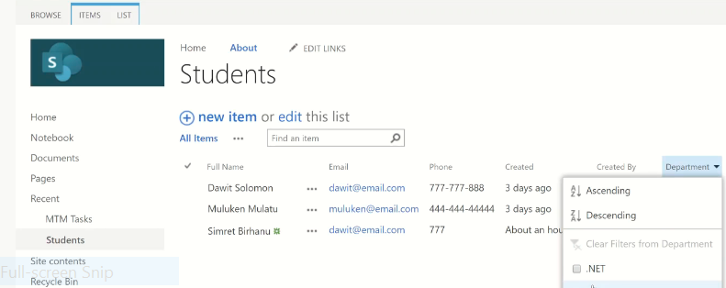

Save this view

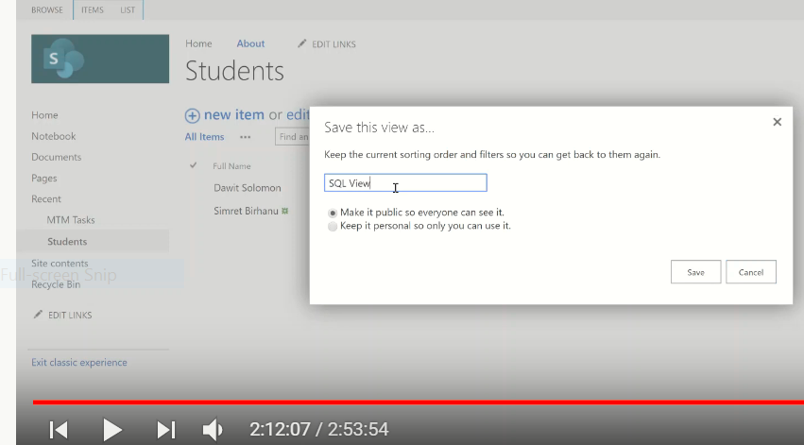

3 ways

* Drop down
* Save this view
* List=>view

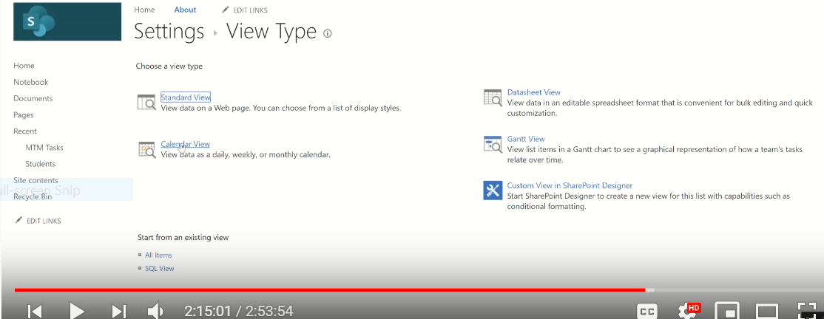

### 3.12.1.Tabolar view

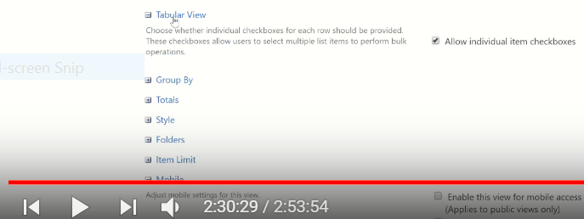

## 3.13.Group:Group by department

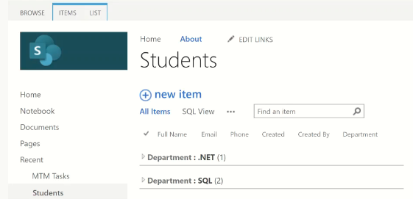

Assigned today

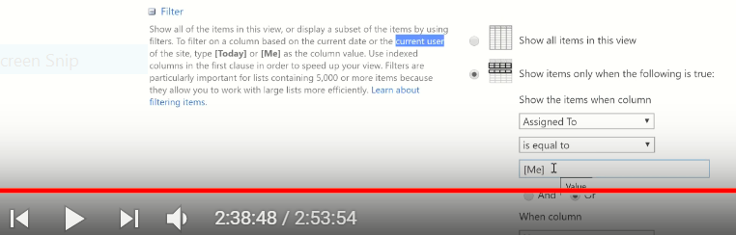

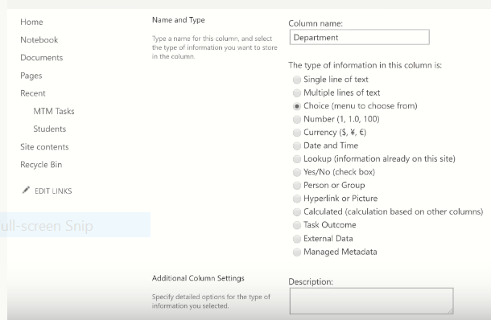

**///////////////////////////////////////////////////**

# MTM Students

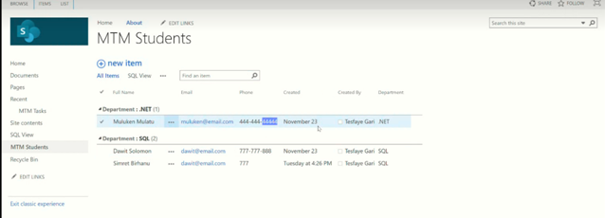3.14.Versioning

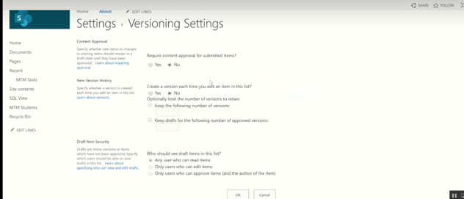

**Advanced setting d/t in MTM task and..**

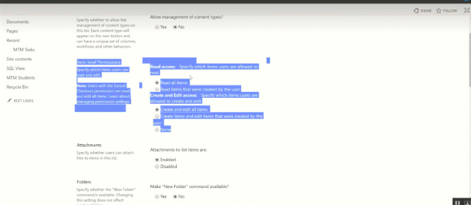

## 3.15.Item level permission

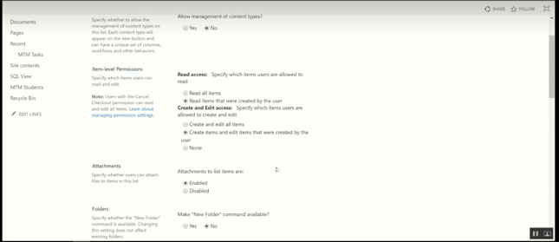

## 3.16.Attachment

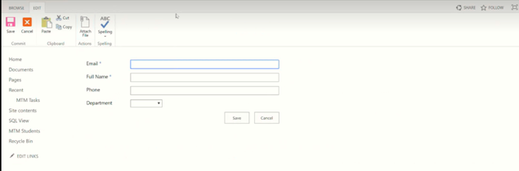

**Look from top**

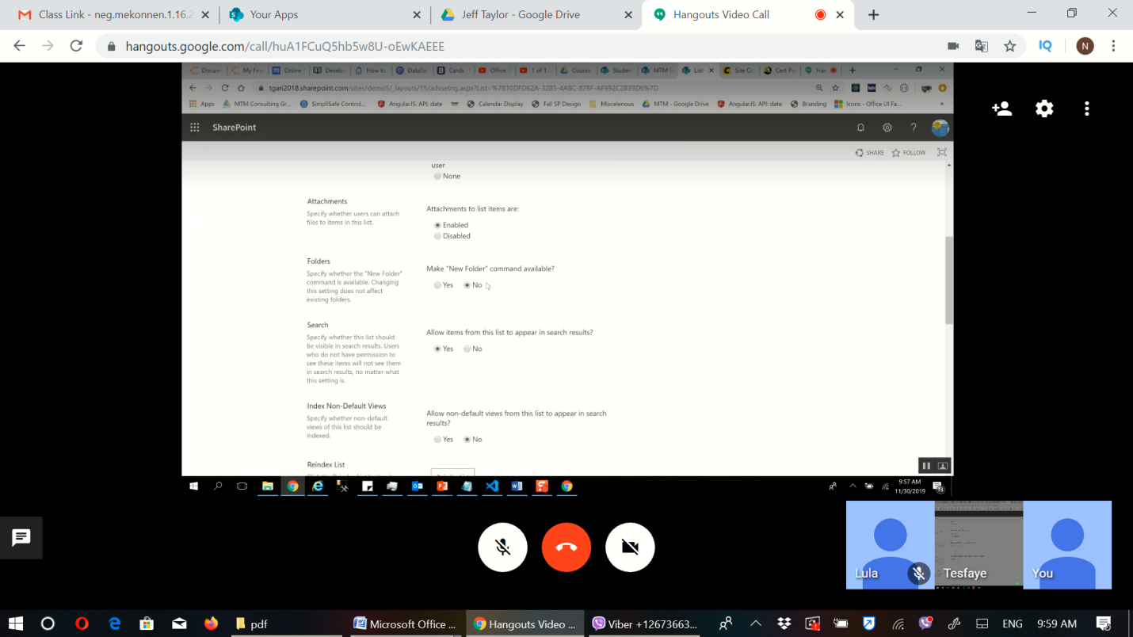

### Re-index

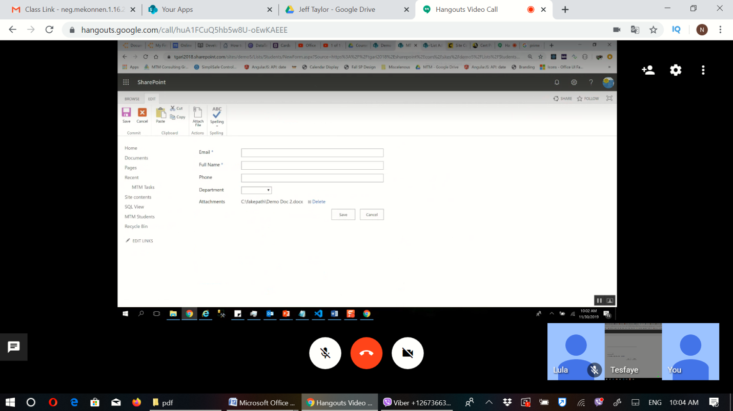

### Google as index

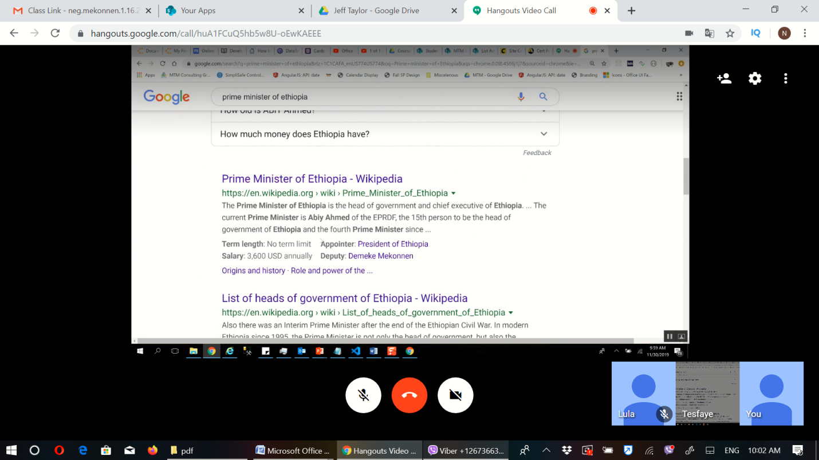

**Dealog box..biger**

### Popup..smaller

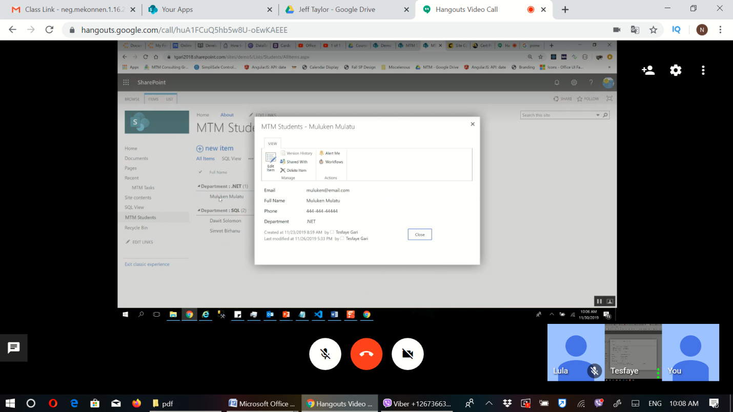

### Audiance

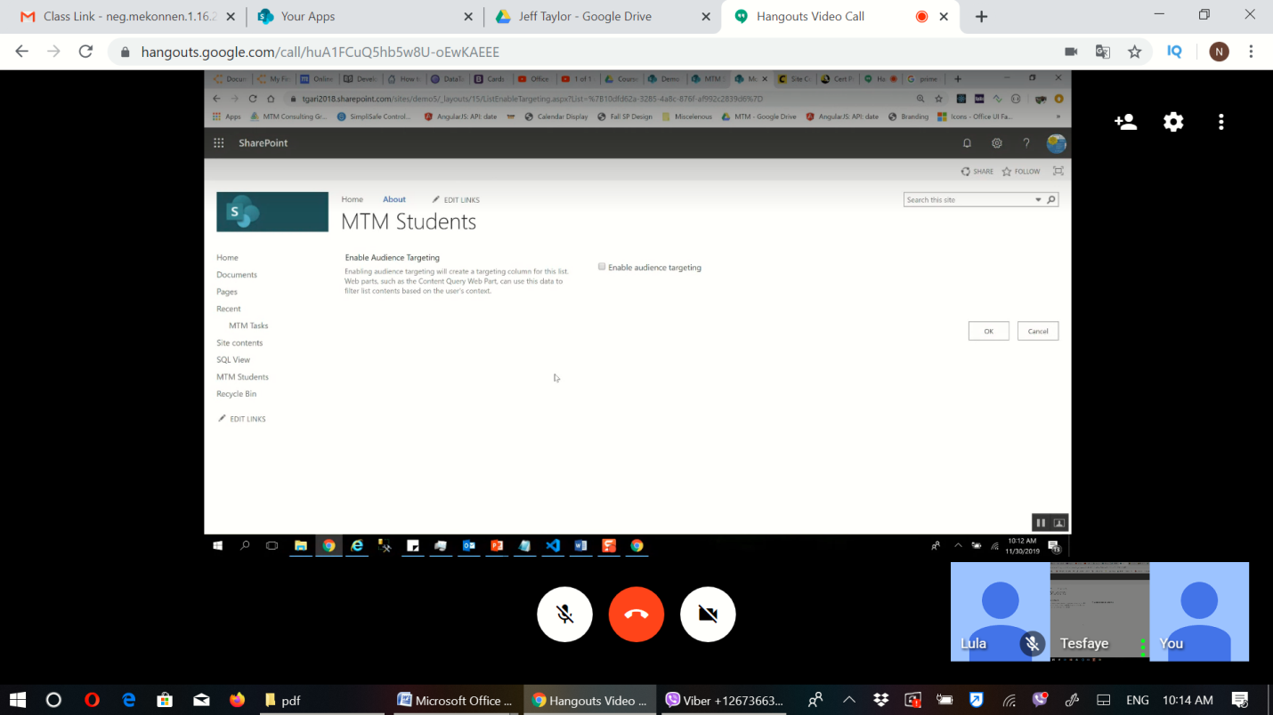

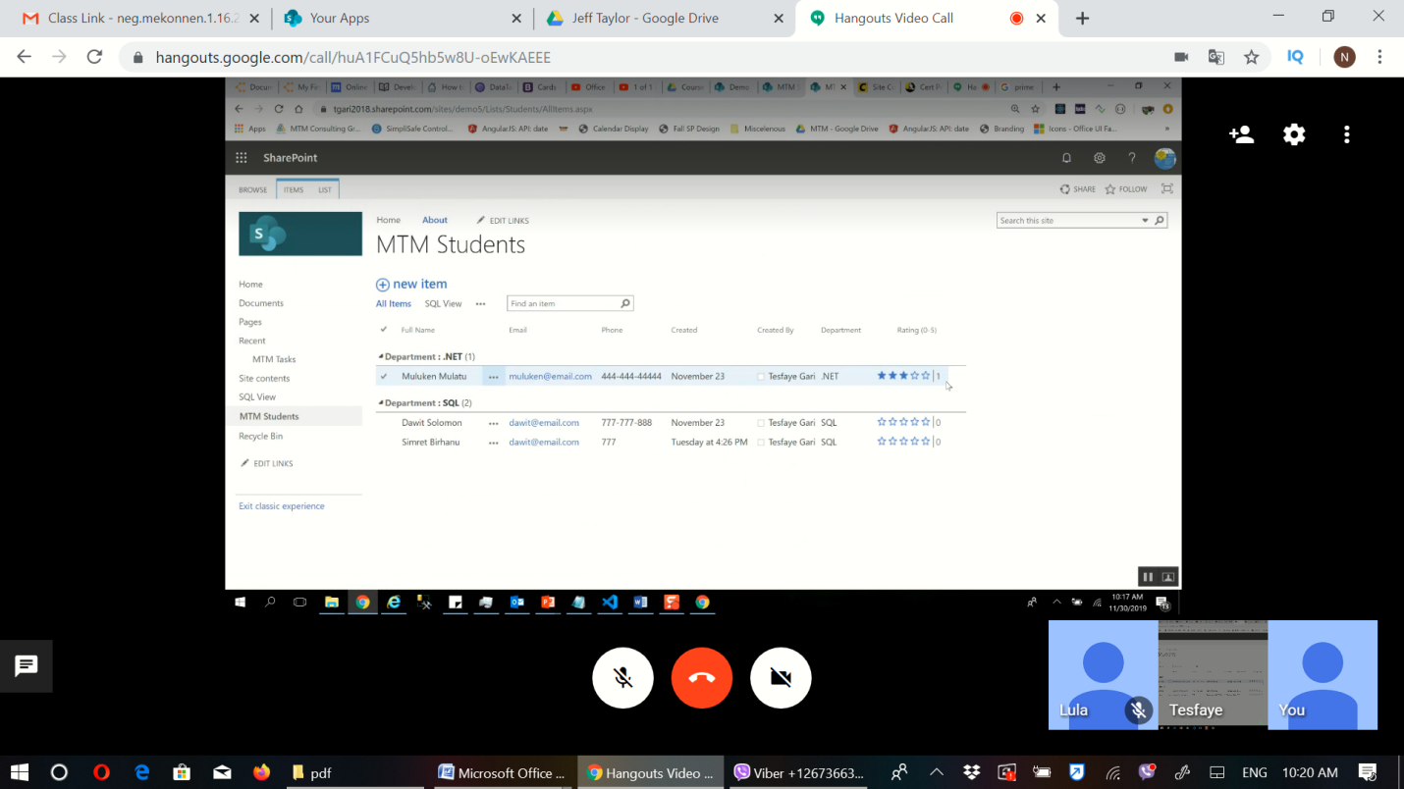

### Save as a tamplet

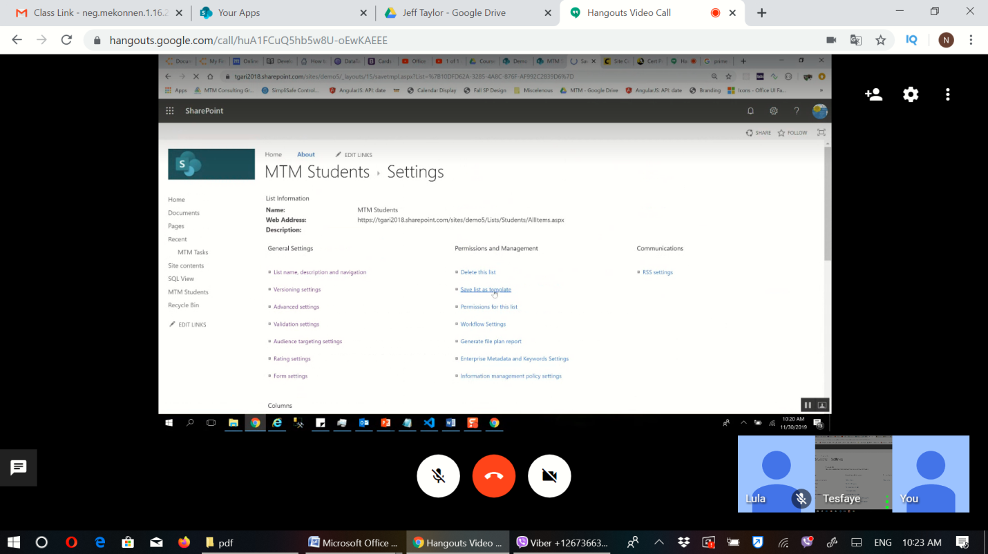 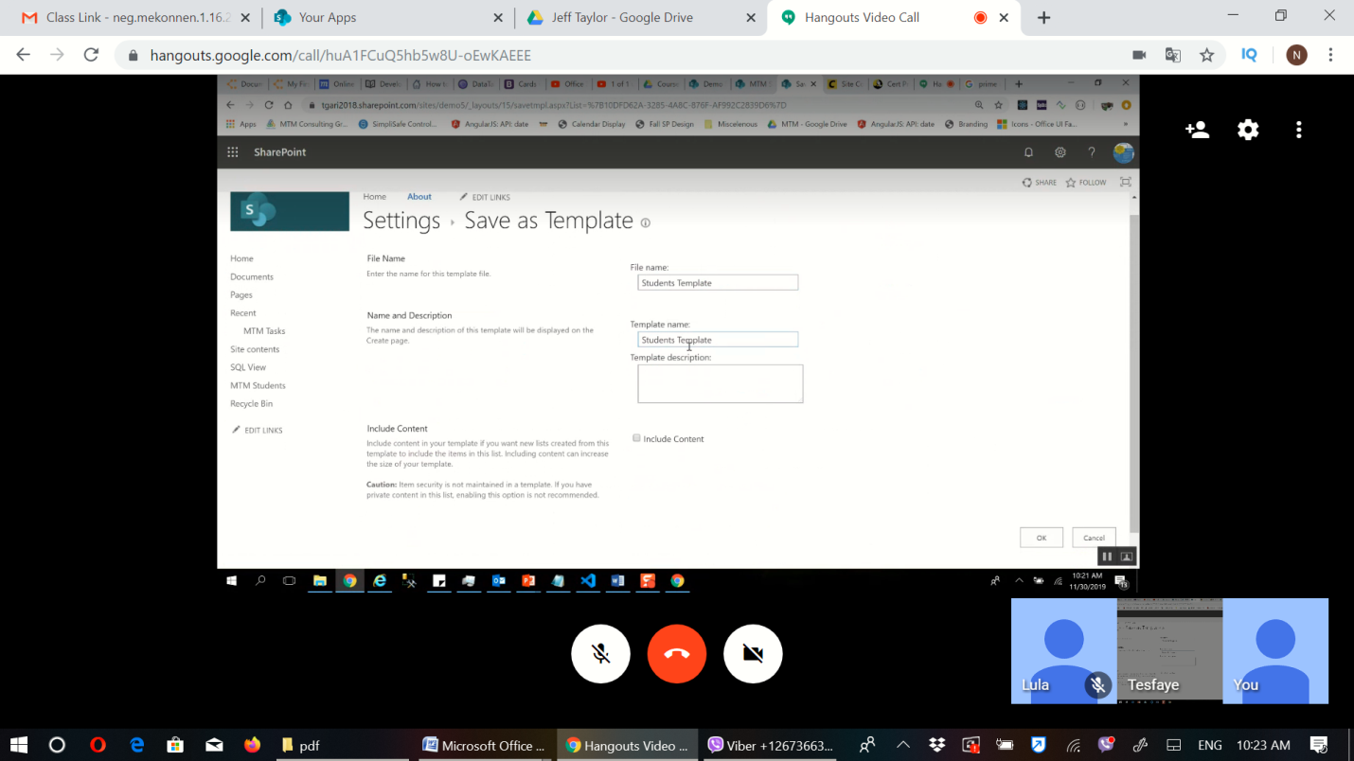

#### Gallery

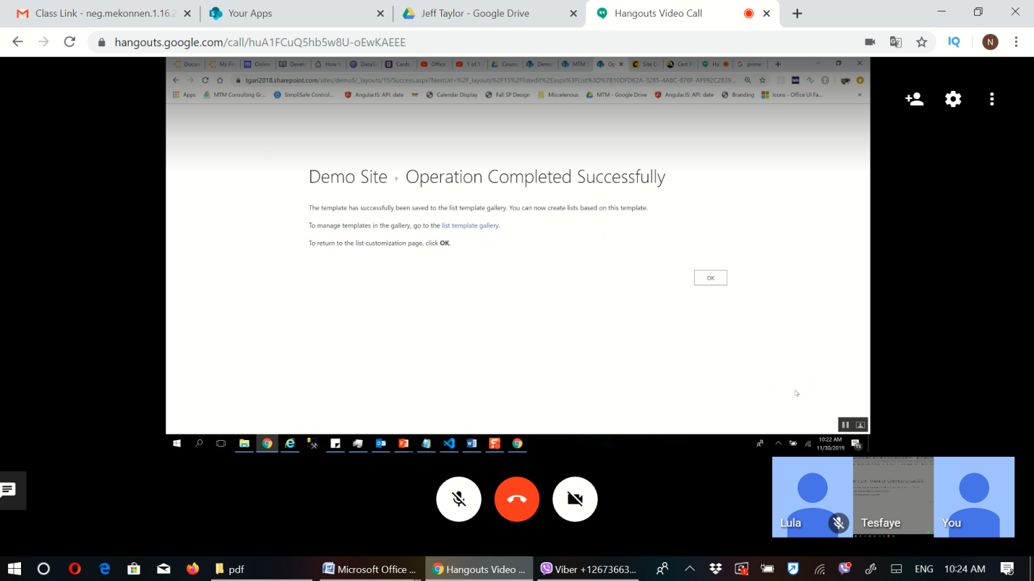

### Download Tamplet

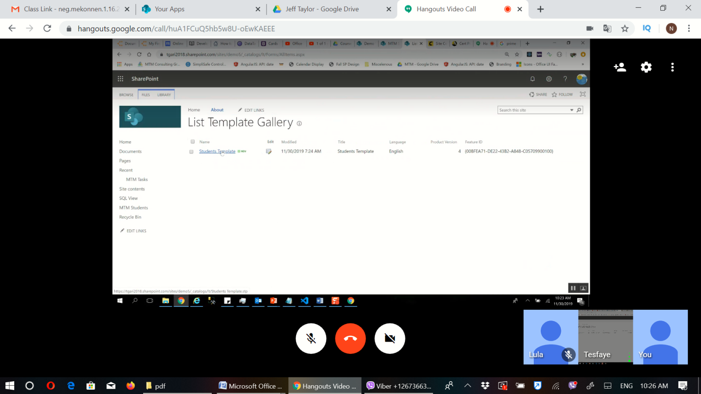

## Then create new Student list and upload it to get copy

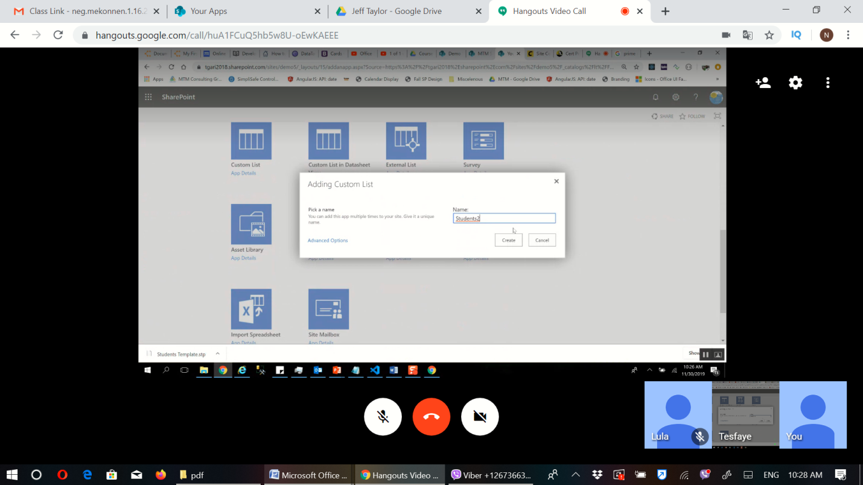

Copy like this

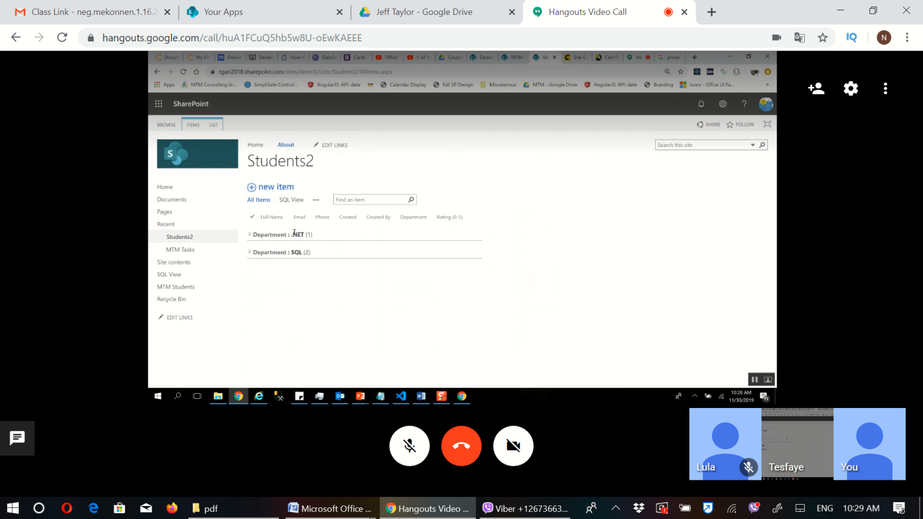

## Enterprise metadata and keyword settings

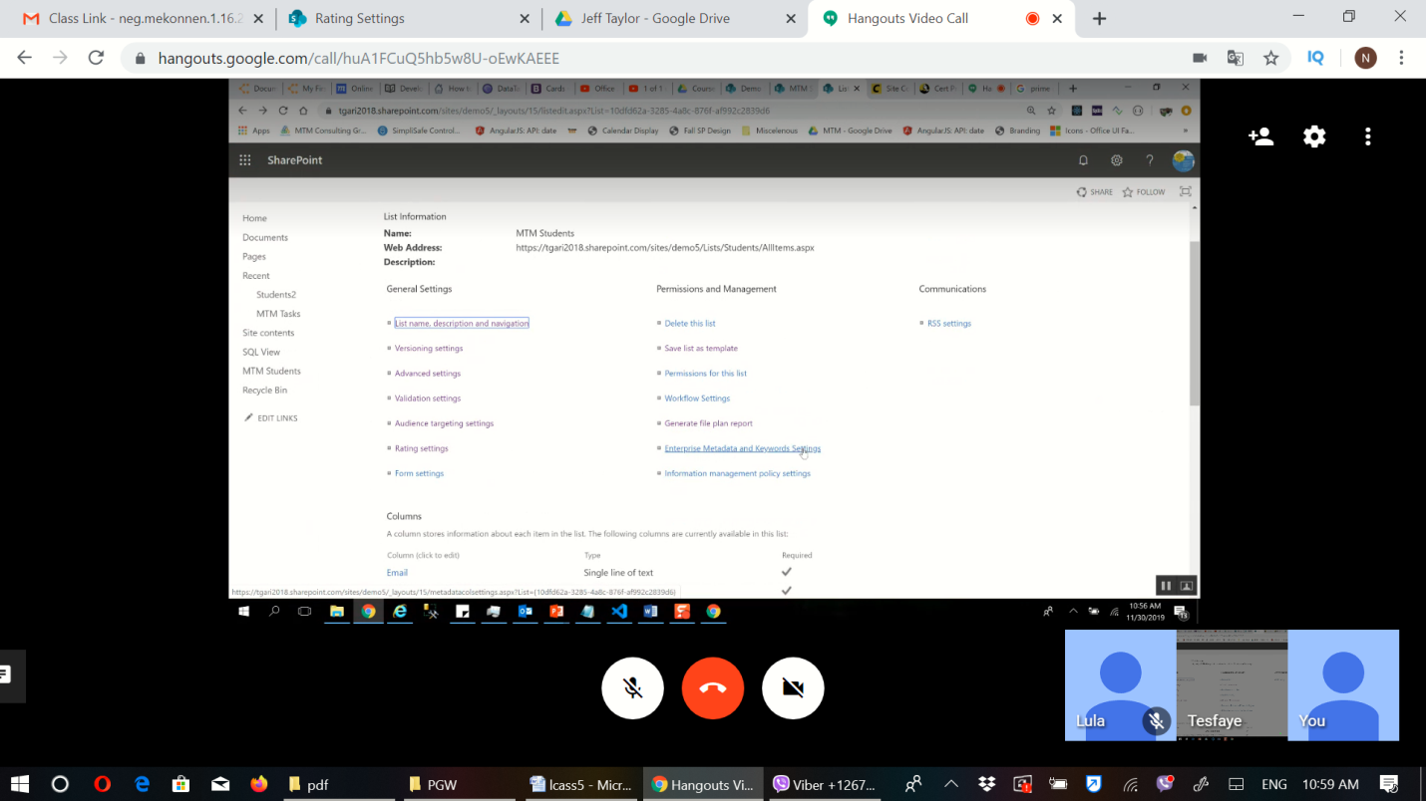 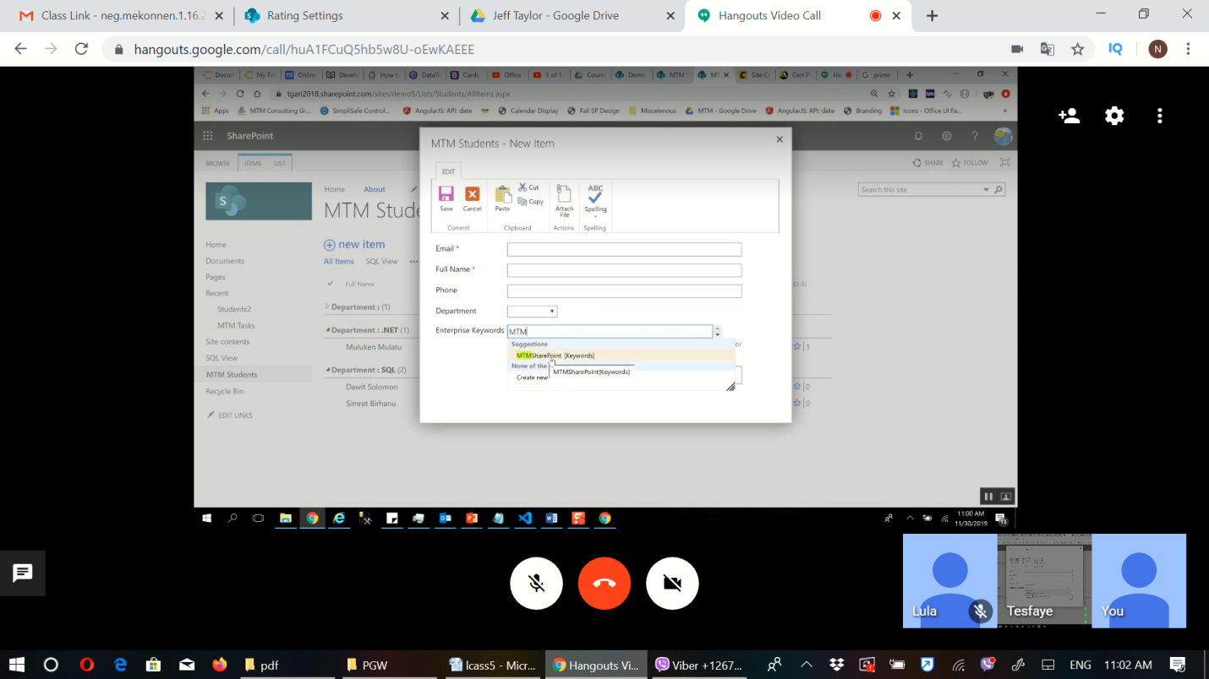 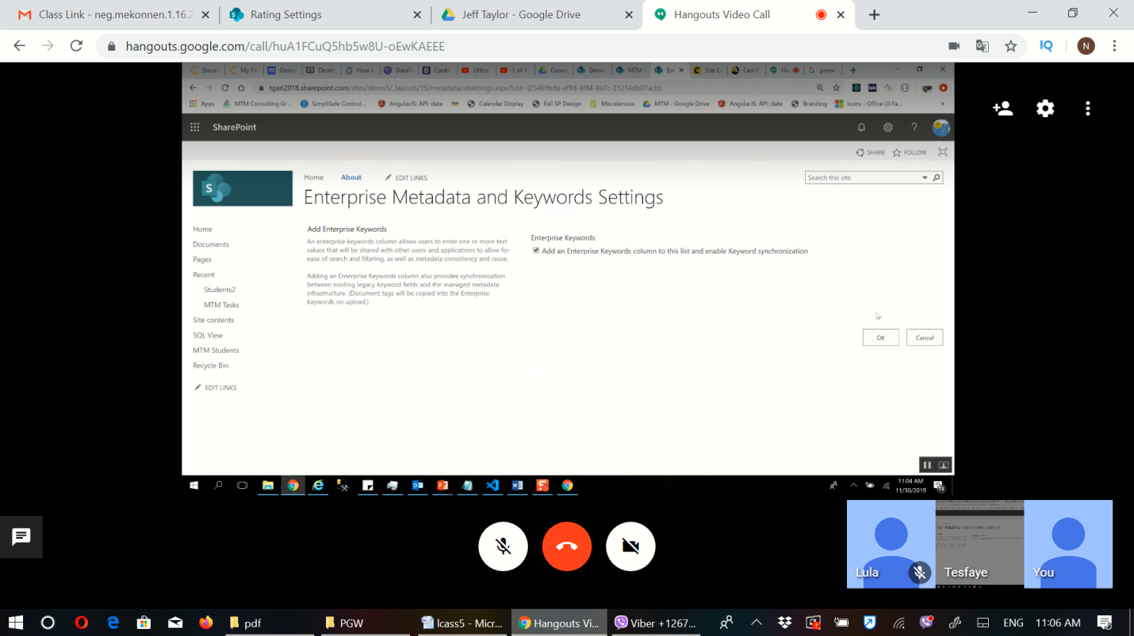 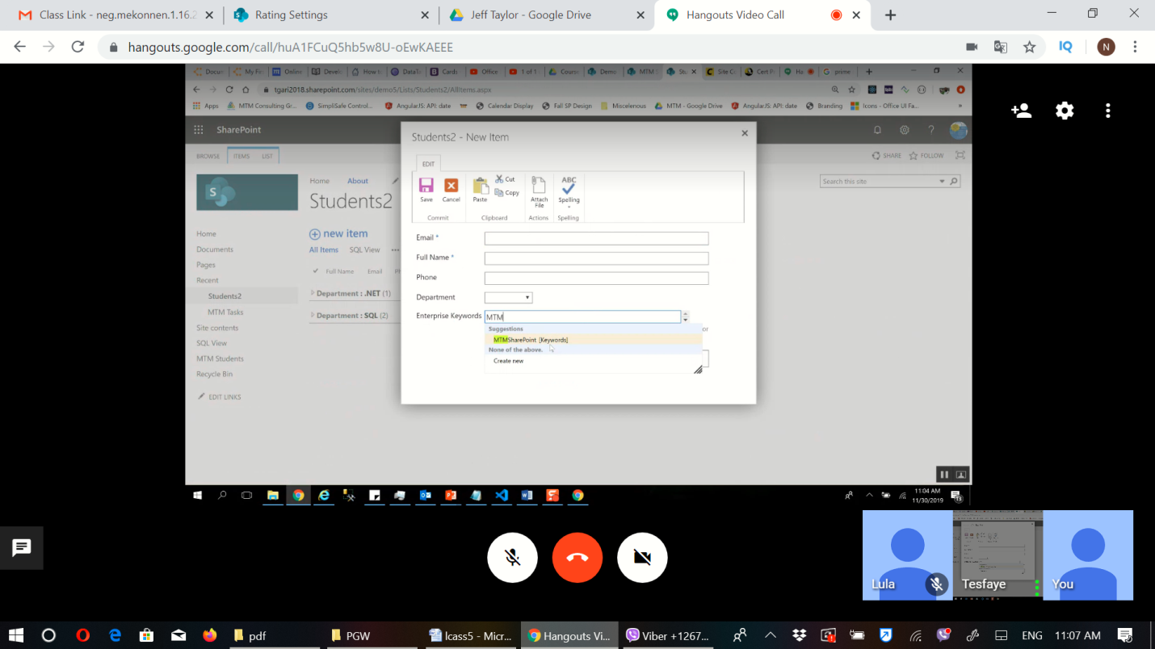

One tag must come first

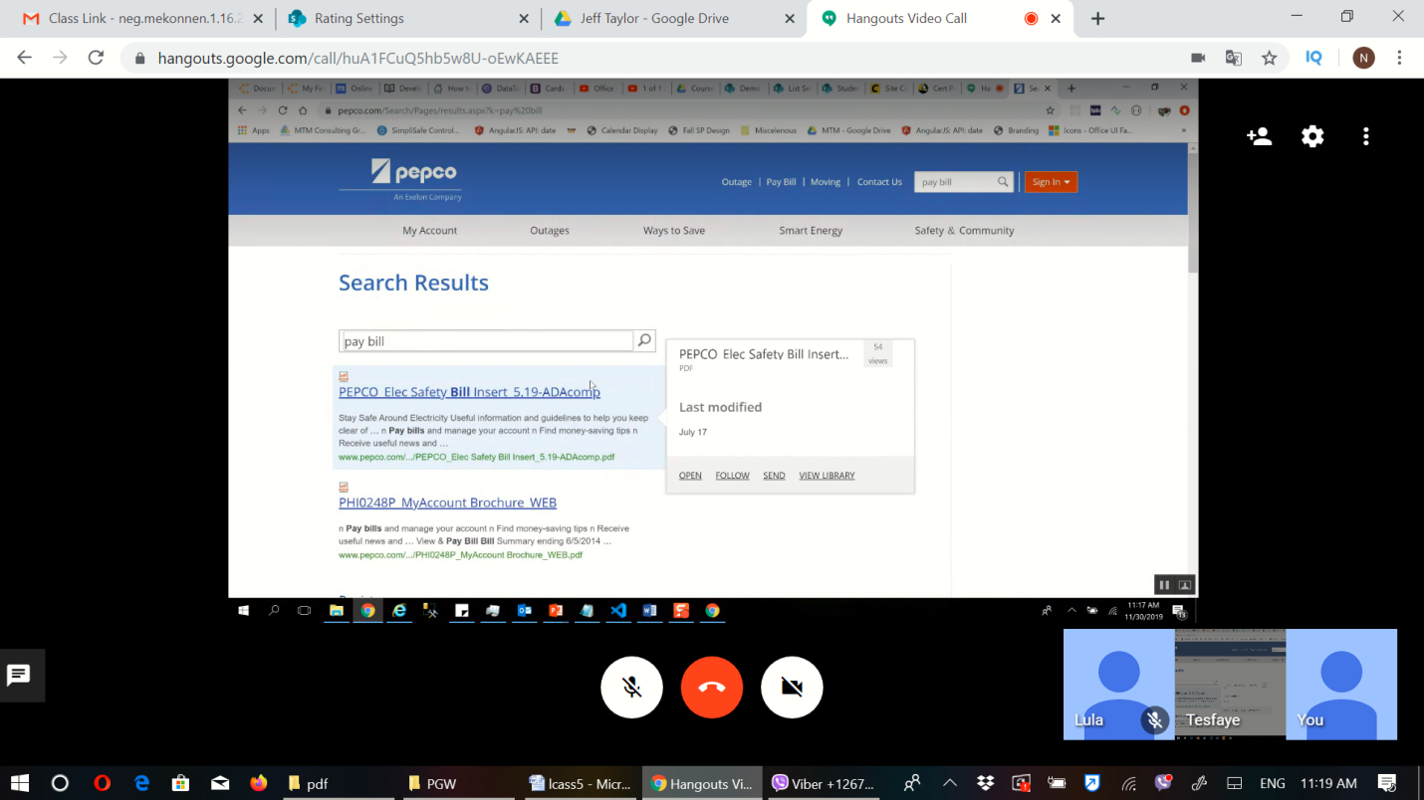

## Information management policy settings

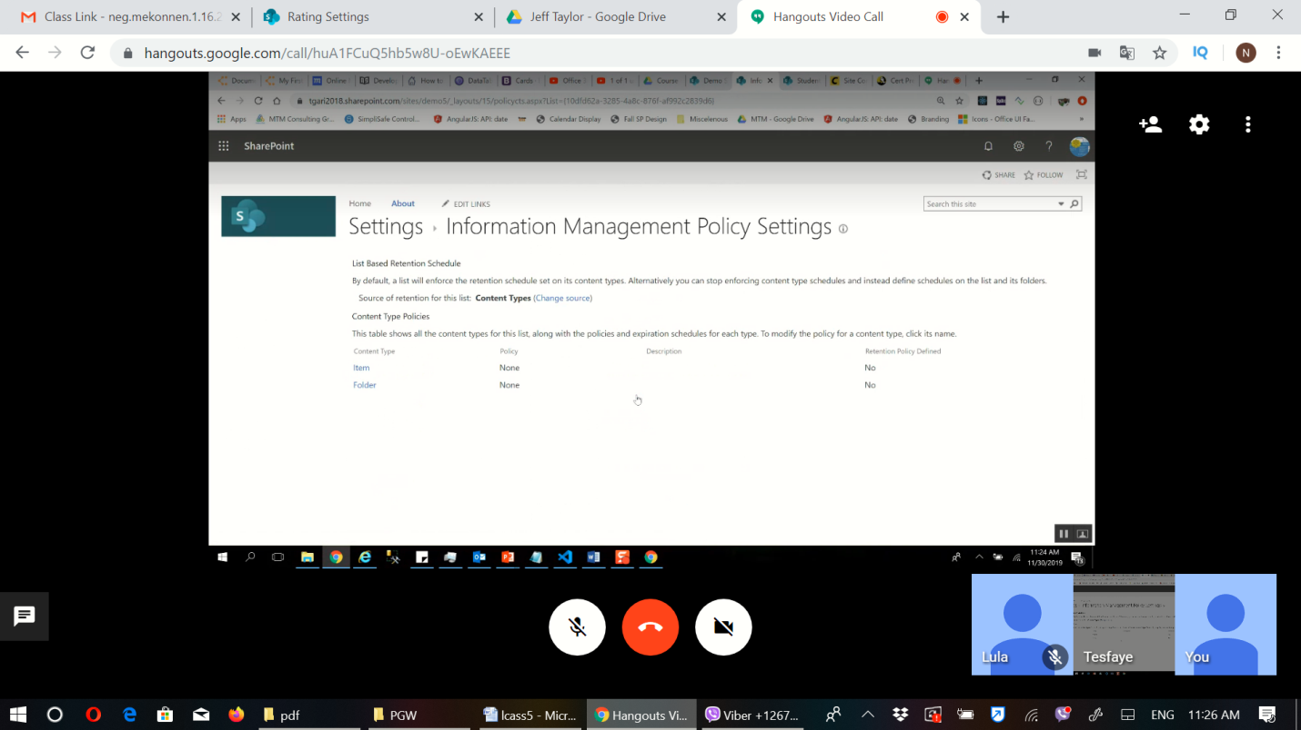

### Retention

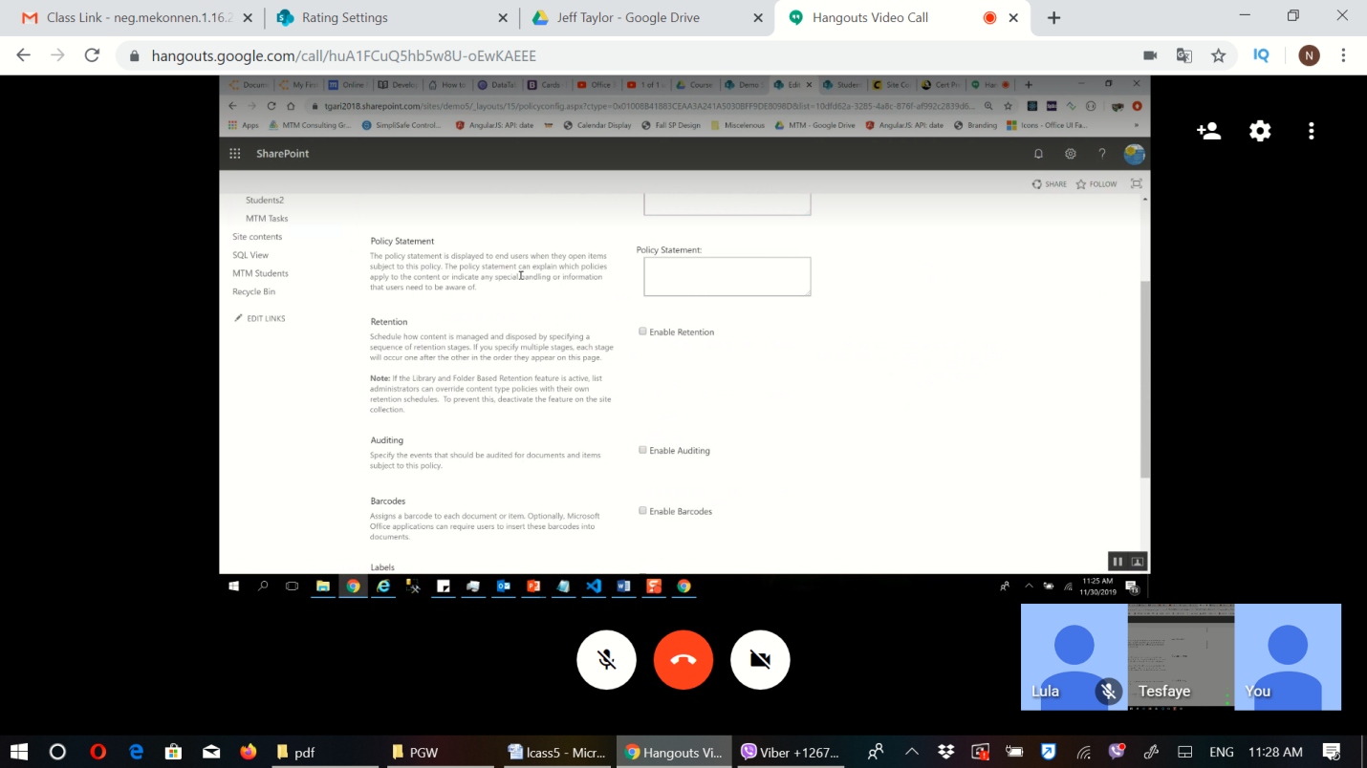 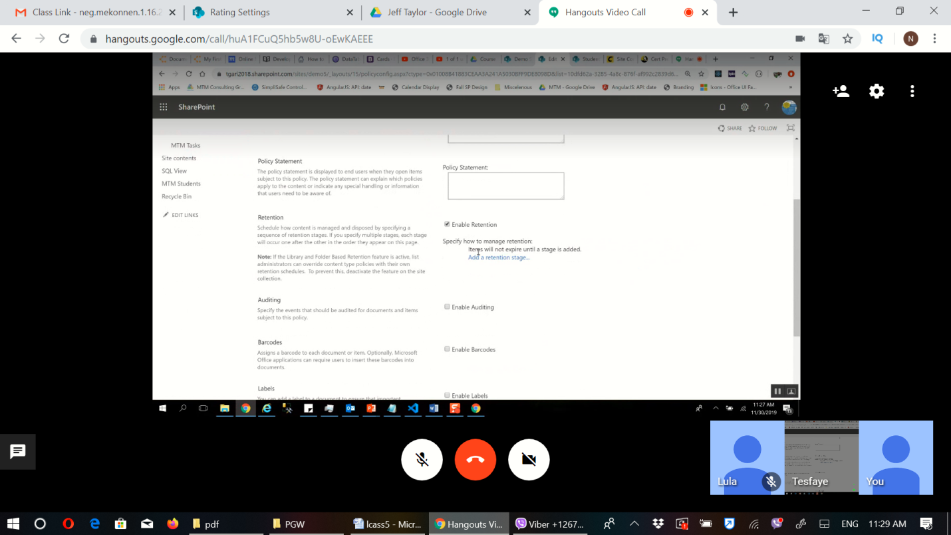

### Time period

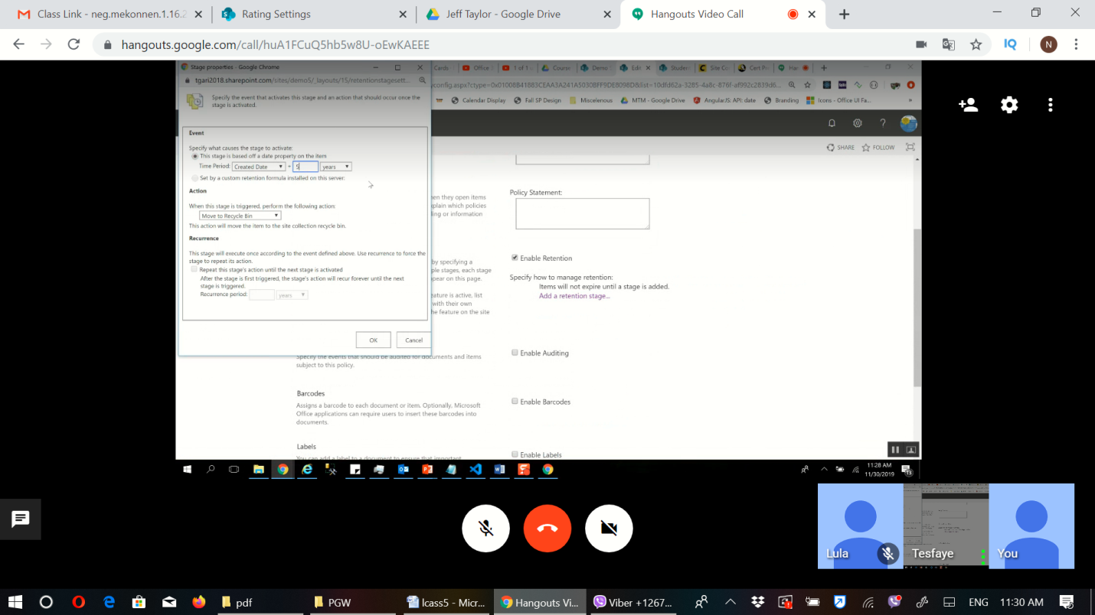

### Transfer

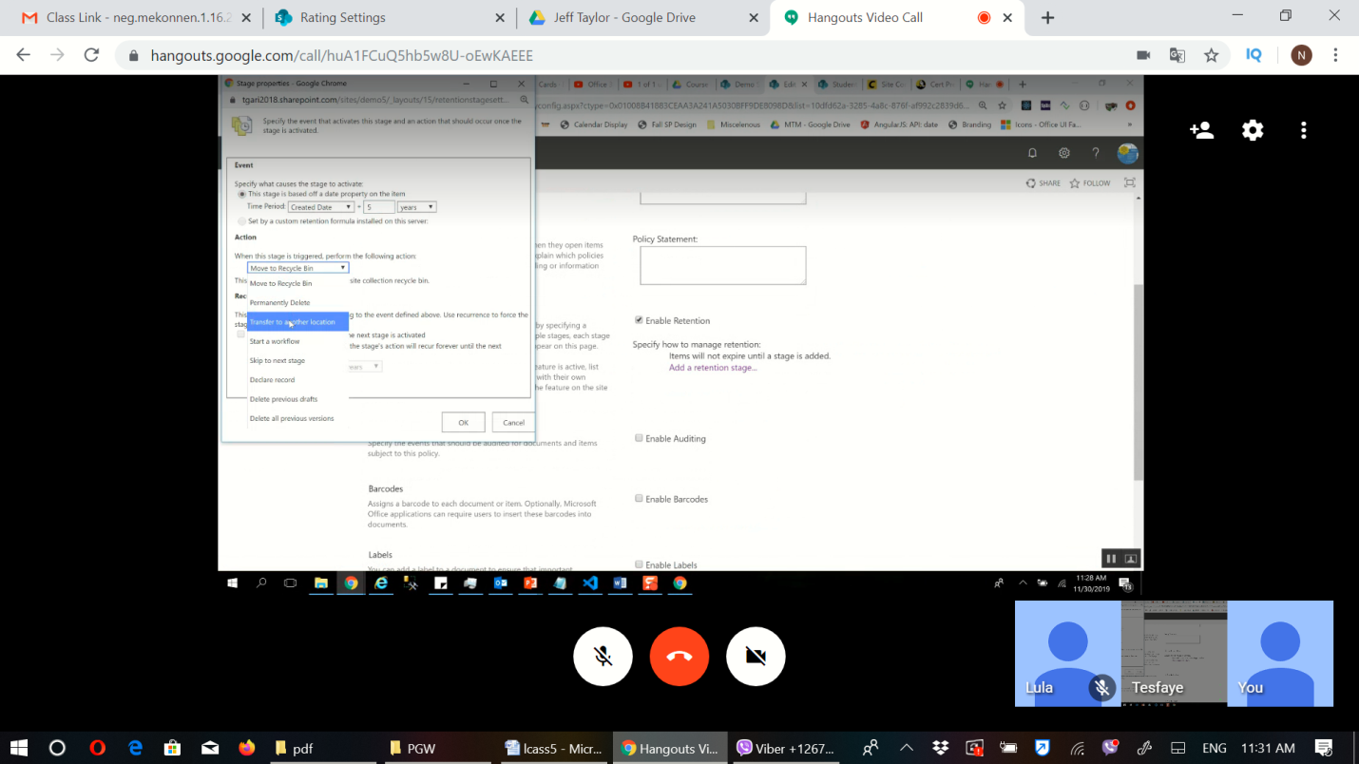

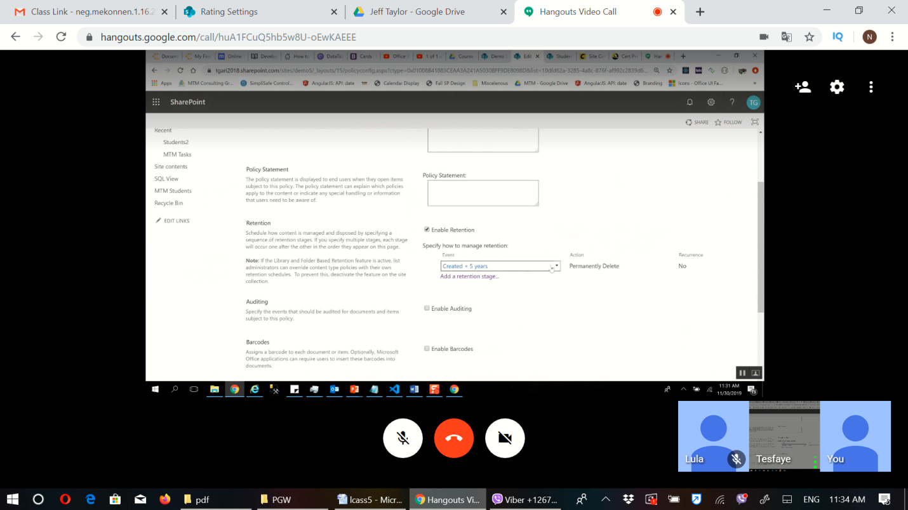

# Library

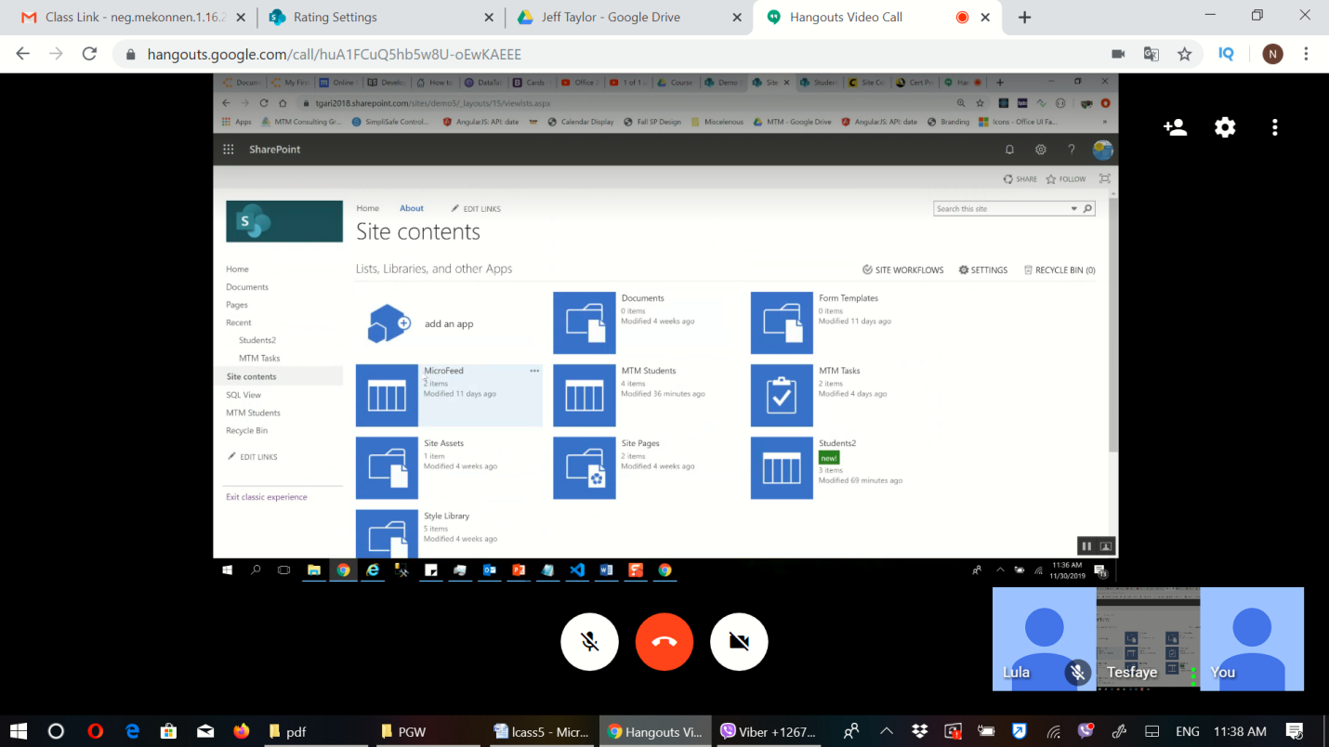

Delete

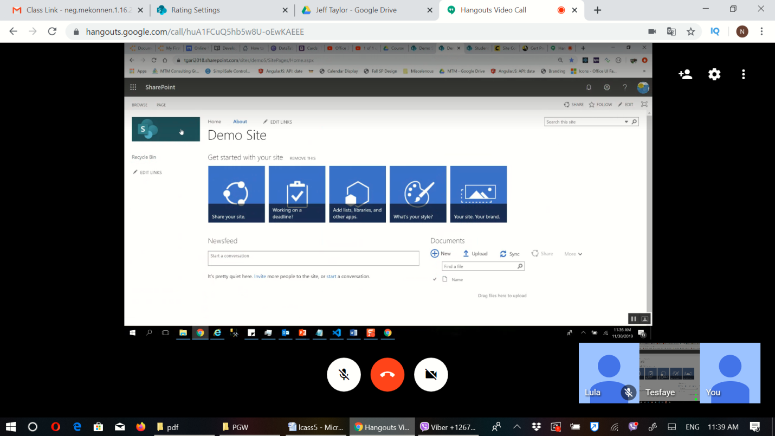 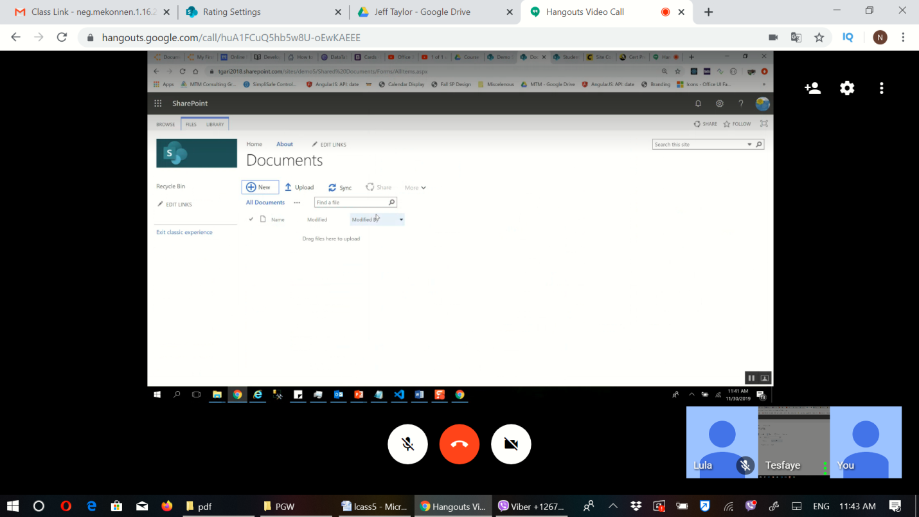 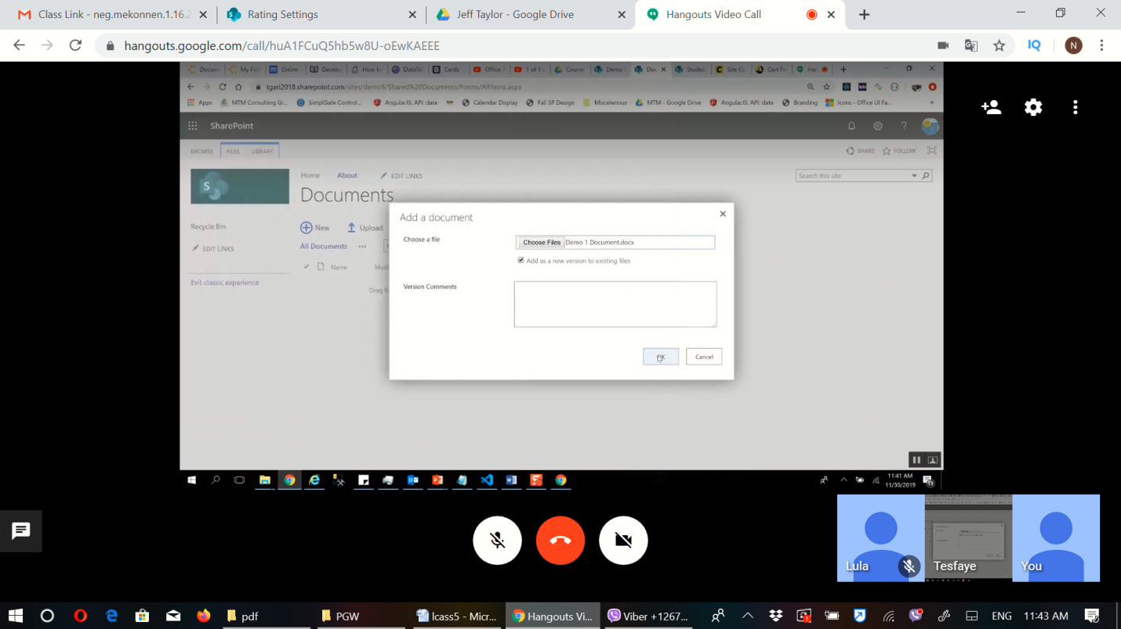 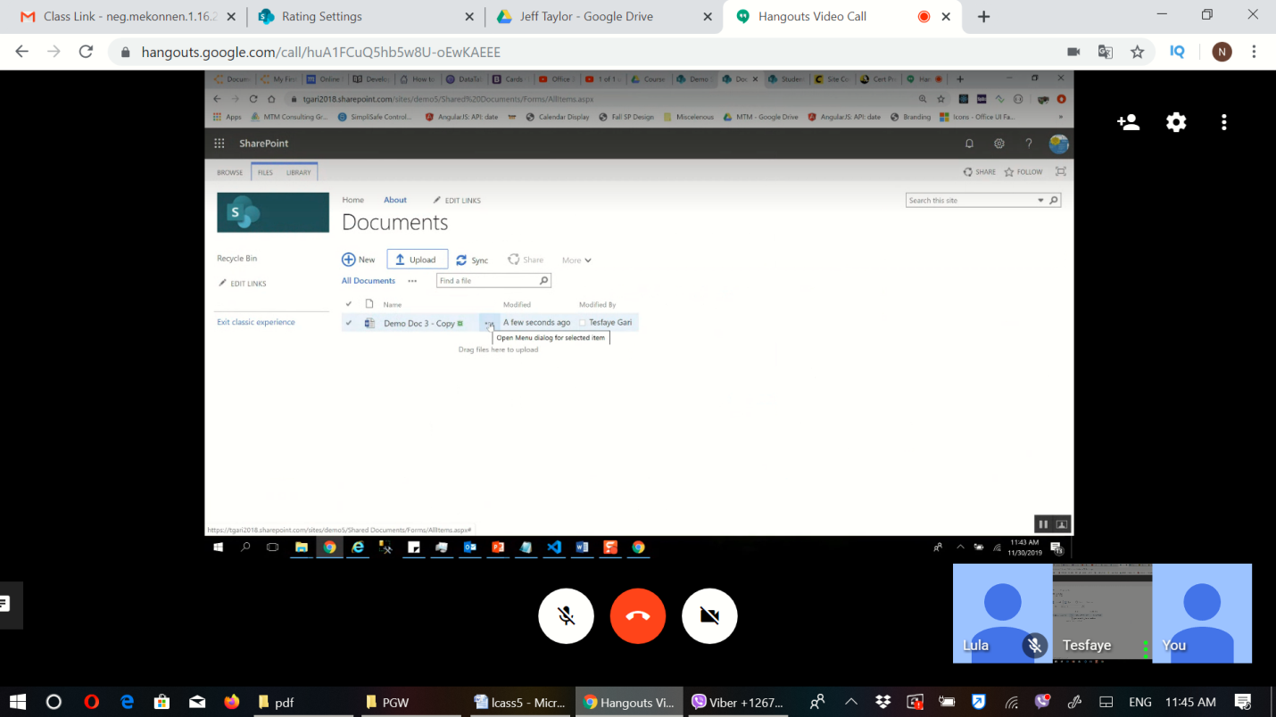

### Contextual menu

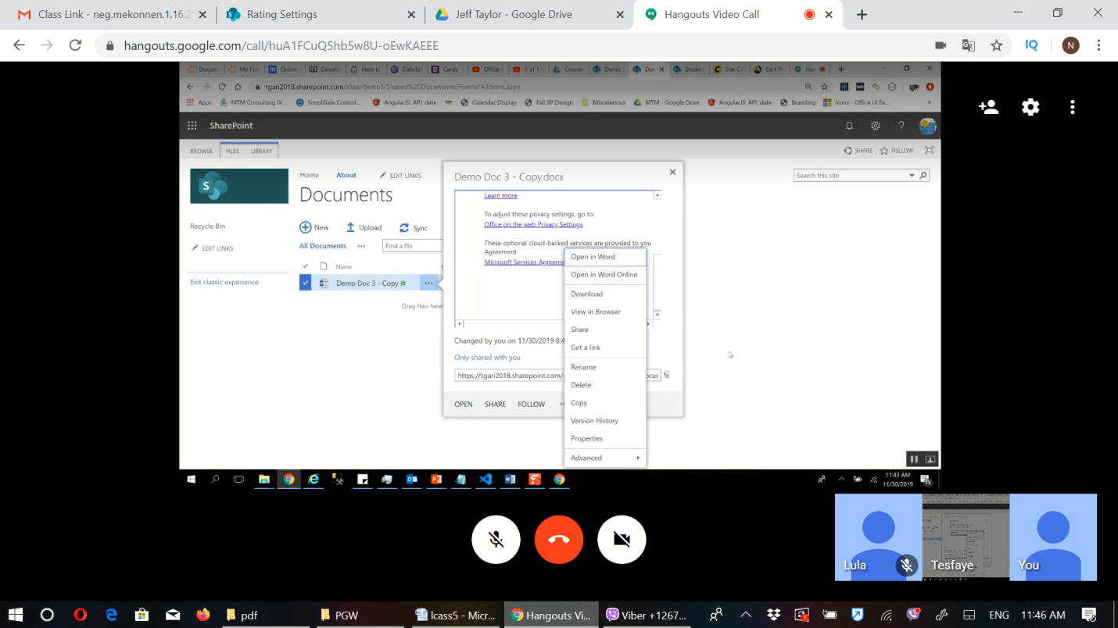

## Checkout

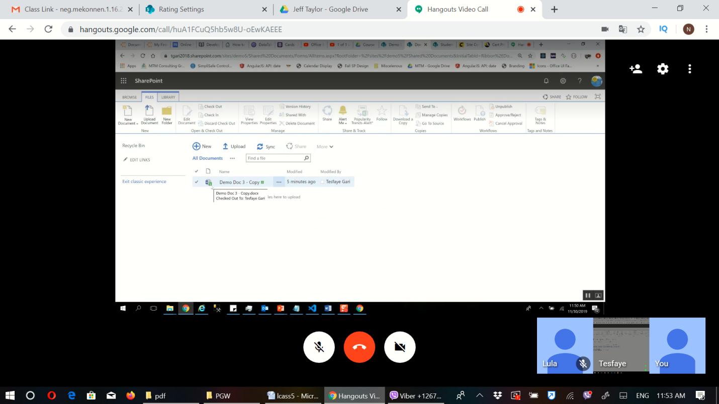

## Open the word online or …

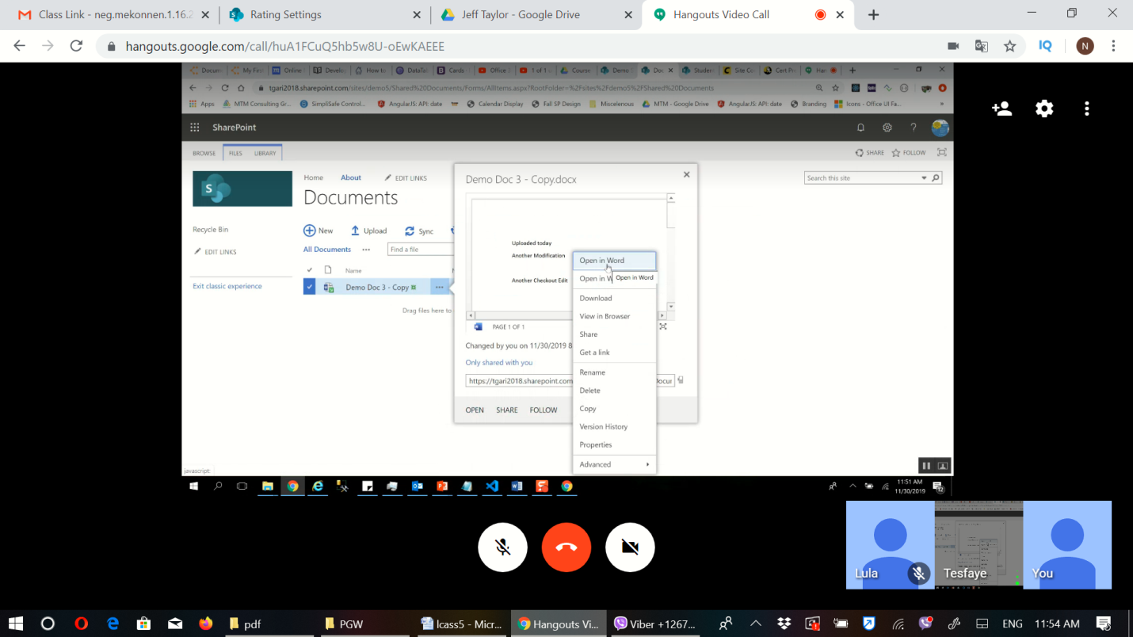

## Add another column

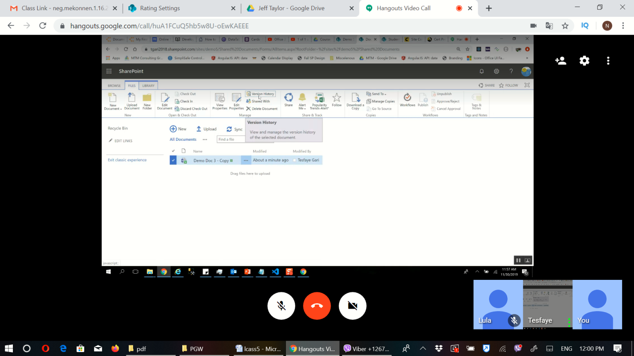 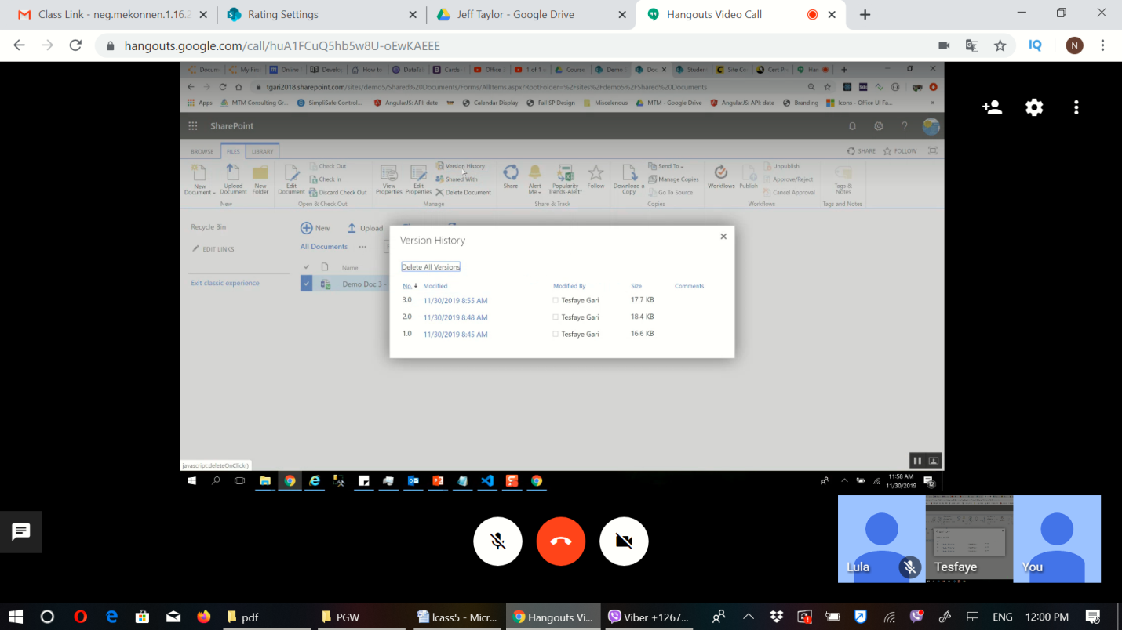 modify view

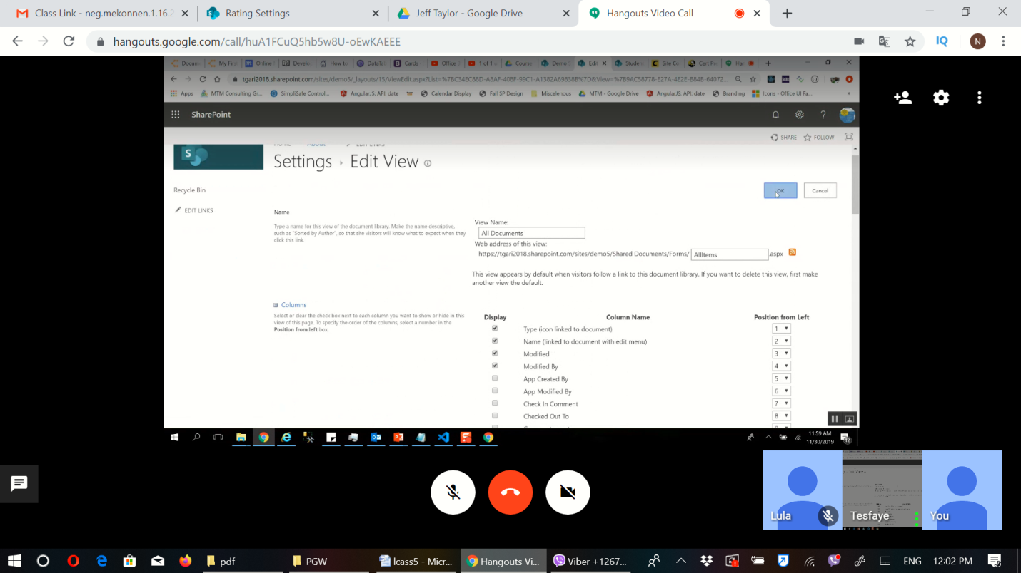

## Discard

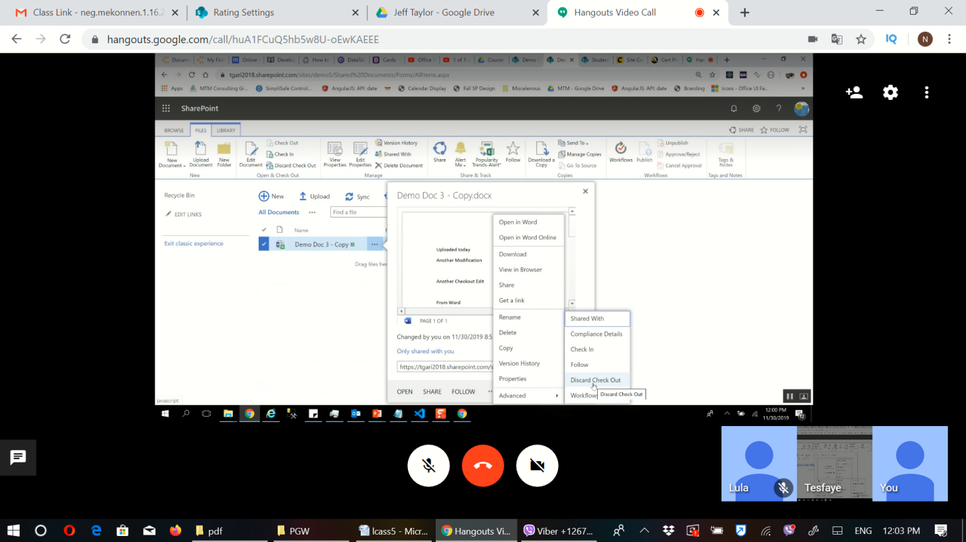 upload

